Bewerbungsformular für EFD Projekte von „IN VIA Köln e.V.“
Application Form for EVS projects of „IN VIA Köln e.V.“:
IN VIA - Kath. Verband Katholischer Mädchensozialarbeit Köln e.V.
Co-ordinating Sending and Hosting Organisation
for the European Voluntary Service
c/o Teresa-von-Avila-Haus
Spielmannsgasse 4-10
50678 Köln
Fon 0049- (0)221- 931810- 19
Fax 0049- (0)221- 931810- 20
www.INVIA-Koeln.de
evs@invia-koeln.de

Liebe Bewerber,
bitte beantworten Sie die Fragen auf Englisch oder noch besser auf Deutsch.
(Dear applicant, please answer the questions in English or better, in German.)
Sie brauchen nicht so antworten, wie es vielleicht gewünscht ist, sondern seien Sie bitte ehrlich! Danke!
(You do not need to be modest, just be honest! Thank you!)
1 Name wie er im Reisepass steht (name written as in the passport):
2. Adresse (address):
3. Nationalität (nationality):

4. Name Ihrer Entsendeorganisation (name of your sending organization):
5. Ansprechperson und Kontaktdaten der Entsendeorganisation (contact person and contact details of your sending organization):
6. Notfall Kontakt (z.B. Eltern: Name, Adresse, E-Mail, Telefon) (emergency contact (e.g. parents: name, adress, E-Mail, Telefon)):

7. Deutschkenntnisse (german level)
A1 (total beginner)
Can understand and use familiar everyday expressions and very basic phrases aimed at the satisfaction of needs of a concrete type. Can introduce him/herself and others and can ask and answer questions about personal details such as where he/she lives, people he/she knows and things he/she has. Can interact in a simple way provided the other person talks slowly and clearly and is prepared to help.
A2 (beginner)
Can understand sentences and frequently used expressions related to areas of most immediate relevance (e.g. very basic personal and family information, shopping, local geography, employment). Can communicate in simple and routine tasks requiring a simple and direct exchange of information on familiar and routine matters. Can describe in simple terms aspects of his/her background, immediate environment and matters in areas of immediate need.
B1 (average)
Can understand the main points of clear standard input on familiar matters regularly encountered in work, school, leisure, etc. Can deal with most situations likely to arise whilst travelling in an area where the language is spoken. Can produce simple connected text on topics which are familiar or of personal interest. Can describe experiences and events, dreams, hopes & ambitions and briefly give reasons and explanations for opinions and plans.
B2 (advanced average)
Can understand the main ideas of complex text on both concrete and abstract topics, including technical discussions in his/her field of specialisation. Can interact with a degree of fluency and spontaneity that makes regular interaction with native speakers quite possible without strain for either party. Can produce clear, detailed text on a wide range of subjects and explain a viewpoint on a topical issue giving the advantages and disadvantages of various options.
C1 (good)
Can understand a wide range of demanding, longer texts, and recognise implicit meaning. Can express him/herself fluently and spontaneously without much obvious searching for expressions. Can use language flexibly and effectively for social, academic and professional purposes. Can produce clear, well-structured, detailed text on complex subjects, showing controlled use of organisational patterns, connectors and cohesive devices.
C2 (very good)
Can understand with ease virtually everything heard or read. Can summarise information from different spoken and written sources, reconstructing arguments and accounts in a coherent presentation. Can express him/herself spontaneously, very fluently and precisely, differentiating finer shades of meaning even in the most complex situations.
8. Wie haben Sie Ihre Deutschkenntnisse erlangt? (How did you learn German?):
9. Haben Sie Sprachnachweise (Schulzeugnis, Kurs- Bescheinigung…)? (Do you have any proof for your language skills (school certificate, training certificate…)?)
Ja (Yes) (bitte anhängen(please attach it)) (No)
Andere Sprachen (other languages):

10. Aktuelle Tätigkeit (Ausbildung/Beruf) (current activity (education, profession)):
11. Ausbildung (education):
12. Praktische Erfahrungen (practical experiences) :
Berufliche Tätigkeiten (professional activities):
Ehrenamtliche Tätigkeiten (Jugendarbeit, Sozialarbeit, Sport, Kultur) (voluntary work (youthwork, socialwork, sports, cultural…):
Erfahrungen mit Kindern, Jugendlichen oder sozialen Tätigkeiten (experiences with children, youth or other social activities):

13. Fähigkeiten (skills):
Musik (music)

Kunst (art)

Theater (theater)

Computer

Layout/Design

Handwerk (handcraft)

Sport

Sonstiges (others)
14. Haben Sie (chronische, psychische) Krankheiten oder ähnliches, die einer besonderen Berücksichtigung bedürfen? (Do you suffer any kind of (chronicle, psychological) illnesses that need special consideration?
Ja (yes) nein (no)
Wenn ja erläutern Sie dies bitte ausführlich. (If yes please indicate precisely.):

15. Beschreiben Sie Ihren Charakter (describe your character):
16. Beschreiben Sie Ihren Stärken (describe your strengths):
17. Welche Stärken und Fähigkeiten möchtest Du im EFD Projekt einsetzen? (Which strengthes and skills you want to bring in to the EVS project?):
18. Beschreiben Sie Ihren Schwächen (describe your weaknesses):
19. Selbsteinschätzung (self- validation):
Dies dient nicht der Selektion, sondern lediglich dem Versuch, das richtige Projekt für Sie zu finden.
(This is not for selection but helps to find the right project for you)
Eher Extrovertiert (rather extroverted) Eher Introvertiert (rather introverted)

Optimistisch (optimistic) Pessimistisch (pesimistic)

Cholerisch (choleric) Phlegmatisch (phlegmatic)

Einzelgänger (loner; solitary person) Gesellig (sociable)

Sehr zuverlässig (reliable) manchmal etwas unzuverlässiger (sometimes a little unreliable)

Ausdauernd/ Geduldig (patient) Ungeduldig (impatient)

Kreativ (creative) Unkreativ (not creative)

Lerne Sprachen schnell (learn languages fast) Lerne Sprachen nicht so schnell (- not so fast)

Sehr kommunikativ (communicative) ruhig/ schweigsam (quiet person)

Anpassungsfähig (adaptable) Beharre oft auf meinem Standpunkt (I often tough it out)

Sehr diszipliniert (disciplined) Eher etwas undiszipliniert (rather a little undisciplined)

Sehr empathisch (very empathetic ) weniger empathisch (less empathetic)

Sehr eigeninitiativ (very proactive) lasse eher anderen den Vortritt (leave initiatives rather to others)

Zielstrebig (determined) ich lasse mich treiben (I rather wait what is coming)

Pünktlichkeit ist mir sehr wichtig (punctuality
is very important for me) Pünktlichkeit ist mir nicht so wichtig (- not that important)

Kritisch/zweifelnd (critical/ doubtfully) Unkritisch/ Vertrauend (noncritical/trusting)

Direkt (strait forward/say what I think) Indirekt/Höflich (indirect, polite)

Entscheidungsfreudig (like decision making) Unentschlossen (don’t like decision making)

abenteuerlustig, risikofreudig (adventurous) Sicherheitsbedürftig (need security)

Humorvoll, fröhlich (humorous, happy) Ernst (serious person)

Temperamentvoll (temperamental) Ausgeglichen, zurückhaltend (balanced, shy)

Angepasst (adapted) Ausgeflippt (free-spirited)

Chaotisch (chaotic) Ordentlich (proper)

fleißig, ehrgeizig (ambitious) Bequem, gemütlich (convinient)

rational, reflektiert, (rational reflected) Impulsive (impulsive)

religiös (religious) Nicht religiös (not religious)

reserviert (reserved) Sehr offen (very open)

selbstbewusst (self-reliant) Selbstkritisch (self-critical)

sehr selbstständig (very indipendend) Eher etwas unselbständiger (rather a little more dependent)

selbstlos, hilfsbereit (altruistic, helping) Eigene Bedürfnisse sehr wichtig (my own needs are very important)

Übernehme viel Verantwortung
(take responsibility) Übernehme weniger gerne Verantwortung (like less responsibility)
20. Welches Projekt würde am besten zu dir passen? (Which project would match best to you?)

2007-DE-180 Germany Köln, IN VIA OGTS Gemeinschaftsgrundschule Lustheider Straße
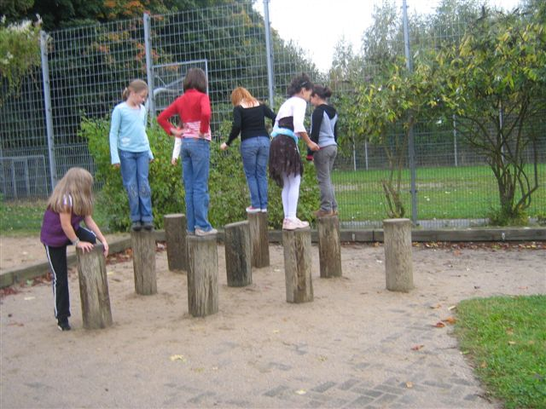
2009-DE-217 Germany Köln, IN VIA OGTS Katholische Grundschule- Primarstufe Alzyer Strasse
2009-DE-218 Germany Köln, IN VIA OGTS Gemeinschaftsgrundschule- Primarstufe Adlerstrasse

The After-School-Clubs are based on the premises of the primary schools. They open at 11 o'clock. The children go there after class and get a warm lunch. Afterwards they do their homework and participate in different workshops such as music, theatre, gardening, sports... The volunteer will work from Monday till Friday from 11- 16.00. In the evening she or he will attend German classes.

Tasks: help in the workshops run for the children, help during lunch, looking after the children, help with homework, help running the holiday programs, it really depends on the volunteers interests.
Reguirements: Basic German would be good, interest in working with children, if possible experiences with children- or youth work. The volunteer should stay for one year which means from 01. September 2012 until 30.August 2013.

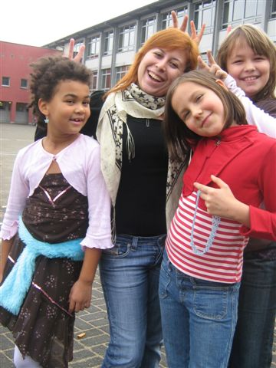
It is important that you like working with children of that age group (6 and 10 years). You would also eat in the project – with the kids. The centre is open during school times. You will be asked to take your vacation during the school breaks at Christmas, Easter, six weeks in Summer and two weeks in October.

Good match not for me

2011-DE-123 Germany Köln, Simsalabim e.V. chidlren day- care

The day care center takes care of the children in two groups, each with 20 children aged from 2 till 6 years. The opening times are from 7.00 a.m. till 6.00 p.m. The core time when all children are present, is between 9.30 a.m. und 3.30 p.m. Since the opening times are controlled very generous, the employees work in shift times. The volunteer will work 35-hours/week from Monday till Friday. In the evening she or he will attend German classes.

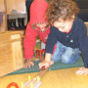
Tasks: The volunteers can participate in all functional areas. Volunteers can work either in the younger groups of 2-3 year old children as well as with the older, 4-6 year old children. Main tasks will be in the child care. This includes for example individual games and plays, take care of the children and organizing different group activities. The volunteers can implement own projects and get help with this. We organize also excursions and sport activities in the gym (Our preschool children go one time per week in the gym of a nearby elementary school for an extra-movement program with lots of games and fun experience) as well as a 3-day children's camp once per year. In the group with the younger children, smaller nursing tasks (swaddling, dressing, etc.) are part of the work. Housekeeping tasks such as cooking, cleaning, washing and dish washing are also part of everyday work and will be taken care of by all employees and volunteers. The volunteer should stay for one year which means from 01. September 2012 until 30.August 2013.

It is important that you are interested and very motivated to work with children and it would be helpful if you had had experience or knowledge in working with children.

Good match not for me

Accommodation:
Your accommodation is a Catholic monastery, called Don Bosco in the middle of Muelheim which is a district on the right side of the river in Cologne. Muelheim is not located in the city center, but it offers a wide choice of shopping possibilities. The monastery is a five minute walk from the tram station.
The volunteers don’t have to be Christian or follow any Christian traditions in the monetary. The Salesianer monks are a Catholic order, you can find them in the internet: www.salesianer.de. The focus of the monks is charity work: In Muelheim they run the biggest Youth Centre of Cologne. The volunteers have got their own room on the guest floor (one for girls, one for boys) together with the other volunteers, a bathroom with laundry facilities and a kitchen. The volunteers have access to almost all parts of the monastery as there are lounges with TV and Video, a living room, a library and a beautiful garden. They get their own keys and are able to leave the house whenever they want to. They are not in the responsibility of the monks, but they must tolerate their way of living and behave with respect. It is allowed for them to have visitors until 10pm. If e.g. family members like to stay overnight, they can ask in advance, to rent a room for 10,- € a night. The volunteers should always keep the noise down. They are not allowed to have visitors overnight. The volunteer has to clean his own room and the rooms that he shares (kitchen).
We will provide your room with some furniture such as bed, wardrobe, table and chair. In addition we provide plates, cups, glasses, cutlery, bedding, sheets, towels, a pot and a pan. You always have to clean your room yourself. Your accommodation must be clean when you leave. We might ask you to pay a deposit which you get back after your stay. We do not pay phone bills. The volunteers have to pay themselves for a mobile phone.

Monthly Allowance:
You will receive 105 € pocket money and a food allowance according to the sums specified by the national agency.

Local Travel:
We provide a monthly travel card for you. It allows you to use public transport in Cologne. The national agency pays the train tickets to the seminars and back.

Seminars:
During your EVS you have to attend two seminars in Germany. The on-arrival training will be during your first three months. The midterm-meeting will take place in the middle of the year. They are run by the national agency. You will have monthly meetings with the Mentor and the other volunteers.

Working hours:
Volunteers work approx. 35 hours a week, normally from Monday to Friday including language training. According to the project you will be asked to also to work the weekend. You work a maximum of two days a month at the weekend, but you will have another day off instead.

Language training:
We provide you with language courses. IN VIA pays the course and the school book. You do not have to go to language school if your German is good enough to support and work in the project.

Holidays:
For each month that you work with us, you get two days off. If you work in the After School Club you have fixed holidays according to the closing times due to school holidays. Therefore you have only maybe 2 days for your own choice.

21. Wann könnten Sie mit einem EFD Beginnen? (When could you start an EVS?)
22. Wie lange würden Sie gerne einen EFD machen? (How long would you like to do an EVS?)
23. Wären 12 Monate für Sie möglich? (Would 12 months be possible for you?) yes No
24. Was würden Sie tun, wenn der EFD nicht klappt? (What would you do if the EVS doesn’t work out?)
25. Was planen Sie nach dem EFD zu tun? (What do you plan to do after your EVS?)

Wenn Sie noch kein Motivationsschreiben, Lebenslauf und Foto geschickt haben, fügen Sie diese bitte an.
(If you didn’t send motivation letter, CV and a picture jet, please attach them as well.)

Vielen Dank, wir freuen uns auf Ihre Bewerbung!
(Thank you very much; we look forward to receive your application!)

